Channel View Medical Group – New Patient Questionnaire Welcome to our Surgery. Please complete the form and return to reception with your ID. Once the form has been returned our team will review it and you will be contacted if necessary. There are details of the Channel View Team in the Practice leaflet and on our website at www.channelviewmedicalpractice.com which explains the range of services we are able to offer you.
PERSONAL DETAILS
Next of Kin details
Name:
Relationship to you:
Contact number:

Mr Mrs Miss Ms Other |  |  | Surname:
Date of Birth: | / / |  | First names:
NHS No: |  |  |  | Previous name/s:
Male/Female |  |  | Town and Country of birth:
Home Address:
Postcode: |  |  |  |  | Home Telephone number:
Mobile Telephone number: |  |  |  |  | Work Telephone number:
Marital status: |  |  |  |  | Occupation:
Ethnicity: |  |  |  |  | Language:
Email address:
Please help us trace your previous medical records by providing the following information:
Your Previous address in the UK:
Name of previous Doctor while at this address:
Address and telephone number of Previous Doctor:

If you are from abroad….

Your first UK address where registered with a GP:

If previous resident in the UK, date of leaving:
Date you first came to live in UK:

Armed forces and housebound…
Have you ever served in the armed forces?  (Code as Ua0T3) |  | YES / NO
If YES are you still a reservist? (Code as Xabnw) |  | YES / NO
Service or Personnel Number:
Enlistment date: |  | Are you housebound? | YES / NO
Leaving date:

YOUR OWN HEALTH

NHS ORGAN DONOR REGISTRATION
If you want to register your details on the NHS Organ Donor Register as someone whose organs/tissue may be used for transplantation after death. Please tick all that apply and sign this box.
Kidneys | Heart | Liver | Pancreas | Corneas | Lungs | Any of my organs & tissue  YES / NO
Signature confirming my agreement to organ/tissue donation:
Date:
HEALTH PROBLEMS: Please tick if you have a history of any of the following health problems……

Cancer |  | Coronary Heart Disease, Heart Failure, or Artrial Fibrillation
Dementia or Alzheimers |  | Depression or Mental Health problems
Hypertension (High Blood Pressure) |  | Kidney Disease
Respiratory Difficulties  (Asthma or COPD) |  | Stroke or Transient Ischaemic Attacks
Diabetes |  | Learning Difficulties
Epilepsy |  | Thyroid Disease
If you have any other history, important illnesses or disabilities not mentioned above please give details here (include special diet requirements):

ALLERGIES: Please list any allergies you have including drug allergies:
BLOOD PRESSURE: Have you had your blood pressure taken in the last 3 years? What was it? (Please use the machine for self-measurement. Ask at reception for details)
MEDICATION: If you are currently taking any repeat medication, please attach a copy of your repeat prescription to the form when you hand it in. You will need to book a telephone appointment with a GP to discuss your medication. Please make sure you have enough medication to last you until your appointment with the GP.

If on Warfarin, did your previous Practice use INR star? Yes No
REPEAT PRESCRIPTIONS Please indicate where you would like to collect your prescriptions from: Lloyds Pharmacy Well Pharmacy, Regent Street Well Pharmacy, Coombe Park Road Boots, Teignmouth Ross Chemist, Bishopsteignton
Collect from Surgery Other, please state ___________________
YOUR FAMILY HEALTH HISTORY
Have any family members suffered from the following conditions?
Please tick and then circle which family member.

Diabetes (1252) |  | Father / Mother / Sister / Brother
Asthma (12D2) |  | Father / Mother / Sister / Brother
High Blood Pressure (12C1) |  | Father / Mother / Sister / Brother
Stroke (ZV171) |  | Father / Mother / Sister / Brother
Heart Disease (XE24Z) |  | Father / Mother / Sister / Brother
Breast Cancer (XM1Wr) |  | Mother / Sister / Grandmother

YOUR LIFESTYLE

Do you take regular exercise? It is recommended to take five 30 minute episodes of walking type exercise or equivalent a week. Please give details below.

Weight
Height

YOUR SMOKING STATUS (Please tick boxes and complete with information as appropriate)
Never Smoked |  | N/A
Ex- Smoker |  | Date Stopped?
Smoker |  | How many per day?
 |  | Would you like advice/help on quitting? | YES / NO

YOUR ALCOHOL CONSUMPTION  (Circle your answers) |  | 0 | 1 |  | 2 | 3 |  | 4
How often do you have a drink containing alcohol? | NA | Never | Monthly or less | 2-4 times per month |  | 2-3 times per week | 4+ times per week
How many drinks containing alcohol do you have on a typical day when you are drinking? | NA | 1-2 | 3-4 | 5-6 |  | 7-9 | 10+
How often during the past year have you found that you were unable to stop drinking once you had started? | NA | Never | Less than monthly | Monthly |  | Weekly | Daily or almost daily
How often in the past year have you failed to do what was normally expected of you because of alcohol? | NA | Never | Less than monthly | Monthly |  | Weekly | Daily or almost daily
Has a relative/friend or doctor or other Healthcare Professional been concerned about your drinking or suggested you cut down? | NA | No | Yes but not in the past year | Yes, during the past year |  | Weekly | Daily or almost daily

FOR FEMALES AGED 15 TO 65 - if you use any form of contraception please circle which one.
Coil | Depo injection | Implant | Oral Pill | Patches | Other……………………………………………….
If you do use contraception when was your last check-up / review with GP or Nurse? |  |  |  |  | Date:
If you have a Coil or Implant approximately what date was it fitted? |  |  |  |  | Date:
If you have depo injections when was your last one? |  |  |  |  | Date:
Have you had a recent smear? |  |  |  |  | Date: Normal / Abnormal

YOUR DIET

Please tick which of the following you eat regularly (at least twice a week)

Fruit & Vegetables |  | Added sugar
High fibre cereals |  | Cakes/pastries/biscuits
Fish & Chicken |  | Red meat
Semi-skimmed milk |  | Fried food
Pasta/wholemeal bread |  | Butter
Low fat spread |  | Cream

Do you have any specific communication needs? By leaving this section blank we will not record the need for alternative communication methods in your record.
Braille Grade 1
Braille Grade 2
British Sign Language
Contact via Carer/Third party
Easy read
Electronic – Email
Electronic – Text message
Large print front
Interpreter (please state Language) ______________________________
Verbally over the telephone (no written communication)
Other______________________________

SIGNATURE OF PATIENT:
OR SIGNATURE on behalf of a patient:
DATE:
Please note by signing this form you are consenting to receiving texts and emails from the practice.

THANK YOU FOR FILLING IN THIS NHS GP REGISTRATION FORM!

IT HELPS US TO HELP YOU!

CARERS QUESTIONNAIRE

Who is a carer? A Carer is someone, who, without payment, provides help and support to a partner, child, relative, friend or neighbour, who could not manage without their help. This could be due to being elderly, physical or mental illness, addiction or disability.

We would be grateful if you could complete the following questions for the Practice Carer’s Register.
The register enables the practice to proactively manage carer’s needs with the practice and to consider the provision of services to carers. The practice will also ensure that all patients who are carers are informed of and supported in joining the local carer’s link.

IF YOU ARE A CARER PLEASE COMPLETE THIS SECTION

What is your relationship with the person you care for?
Details of the person(s) you are caring for
Title
Surname
Forename
DOB
House name/flat
No. and street
Village
Town
Postcode
Telephone
NHS number
Please contact the following number for advice on a free carers Health and Wellbeing check
03456 434 435

IF YOU ARE BEING CARED FOR PLEASE COMPLETE THIS SECTION
What is your relationship with your Carer?
Details of your carer
Title
Surname
Forename
DOB
House name/flat
No. and street
Village
Town
Postcode
Telephone
NHS number

If you consent to your Carer being informed of any medical information about you which is held at the practice, please sign and date below; if NOT leave blank
Signed: ……………………………………………………………….. Date: …………………………
DIABETES RISK SCORE – QUESTIONS
Please look at the following table below. Please circle your answer and then fill out your points, putting your total points at the end. You can then see your risk level.
Questions | Answer |  | Points
How old are you? | - 49 or younger  - 50 – 59  - 60 – 69  - 70 or older | [0]  [5]  [9]  [13]
Are you female or male? | - Female  - Male | [0]  [1]
What is your ethnic background? | - Only white European  - Other ethnic group | [0]  [6]
Do you have a father, mother, brother, sister and / or own child with Type 1 or Type 2 Diabetes? | - Yes  - No | [5]  [0]
Measure your waist circumference and choose the range | - Less than 90cm (35.3in)  - 90-99.9cm (35.4-39.3in)  - 100-109.9cm (39.4-42.9in)  - 110cm (43in) or above | [0]  [4]  [6]  [9]
Calculate your Body Mass Index (BMI) and choose a range, see attached BMI Chart | - Less than 25  - 25 – 29.9  - 30 – 34.9  - 35 or above | [0]  [3]  [5]  [8]
Have you been given medicine for high blood pressure or told that you have high blood pressure, by your doctor? | - Yes  - No | [5]  [0]
Your total score is: __________ points
Risk Level | Chance of having Type 2 Diabetes now | Chance of high blood glucose now, meaning risk of Type 2 in 10 years | What you need to do
0 – 6 points (Low risk) | 1 in 200 | 1 in 20 | Keep up the good work, make lifestyle adjustments to further reduce risk
7 – 15 Points (Increased Risk) | 1 in 50 | 1 in 10 | Make lifestyle changes
16 – 24 Points (Moderate Risk) | 1 in 33 | 1 in 7 | Make lifestyle changes - see attached Diabetes leaflet
25 or more points (High Risk) | 1 in 14 | 1 in 3 | Arrange a blood test to screen for diabetes

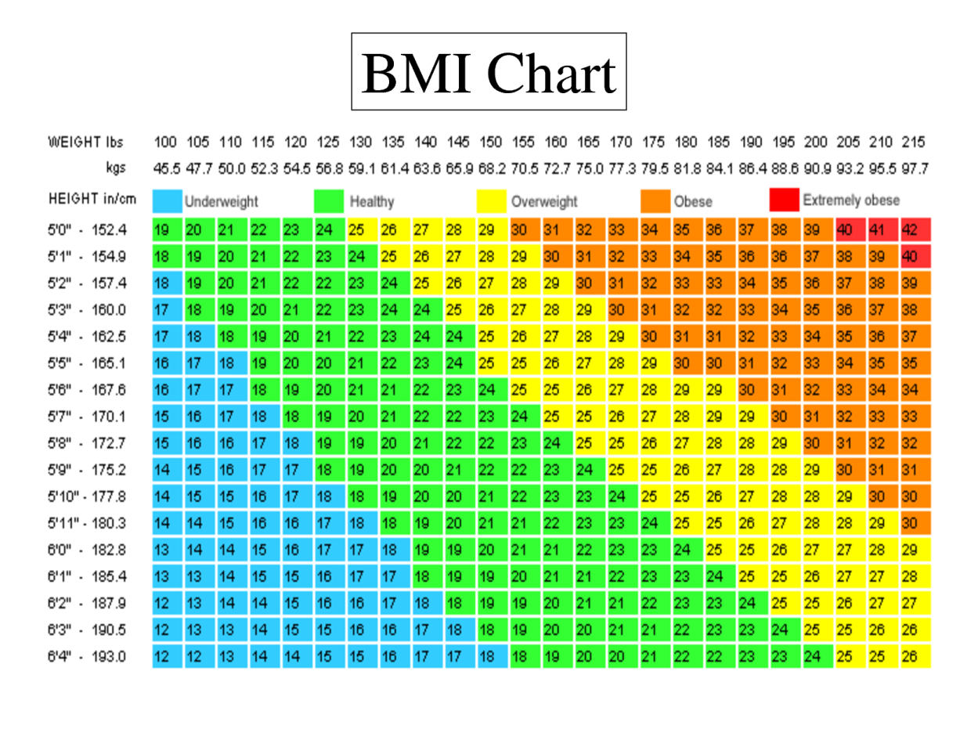

You are more at risk of developing Type 2 diabetes if:
- You are over 40 (or over 25 if you are South Asian)
- You have a close family member with diabetes (parent, brother or sister)
- You are overweight, with a large waist size (over 80cm (31.5 inches) for women, 94cm (37 inches) for men, or 89cm (35 inches) for South Asian men)
- Being South Asian, Black African, African Caribbean – even if you were born in the UK
- You have ever had high blood pressure, a heart attack or a stroke
- You're a woman with polycystic ovary syndrome and overweight
- If you're a woman and you've had gestational diabetes or given birth to a baby over 10 pounds
- If you have a severe mental illness for which you take medication (such as schizophrenia, bipolar illness or depression)
- You've been told you have impaired glucose tolerance or impaired fasting glycaemia.
Note: Some of these risks factors are genetic factors and there is little you can do to reduce them, so it’s best to concentrate on those you can change, such as your weight.

Healthy targets for your waist circumference

 | Waist circumference
Women | Less than 80cm  (31.5 inches)
Men | Less than 94cm  (37 inches)
South Asian Men | Less than 90cm  (35 inches)

Tips to reduce your risk of developing Type 2 diabetes
The following tips can help you to reduce your risk of developing Type 2 diabetes – and keep it low:
- Eat regular meals to keep your blood glucose levels stable.
- Include all the essential food groups every day enjoying at least five portions of colourful fruit and vegetables, starchy carbohydrates (such as grainy bread, wholegrain cereal or oats, pasta, sweet potato or basmati rice), dairy (such as milk, yoghurt, cheese), and a small amount of protein (such as lean meat, chicken, fish, lentils and pulses).
- Choose low-GI snacks such as fruit, yoghurt, reduced fat cheese and wholegrain crackers or unsalted nuts.
- Limit unhealthy snacks high in salt, sugar or saturated fat – this is easier if you avoid processed foods and stick to fresh produce where you can.
- Watch your portions. Eating smaller amounts at main meals and snacks will help with weight loss and improve blood glucose levels.
- Stick to your recommended daily alcohol limit: this is 2–3 units for women and 3–4 units for men.
- Complement your healthy diet with at least 30 minutes of exercise, five times a week – and try not to reward yourself with food afterwards.
- Set yourself goals – mark your milestones and celebrate your successes.
- Variety is the spice of life – experiment with different foods and keep your exercise interesting.
- Start today.

SHARING YOUR NHS PATIENT DATA

Information sharing in the NHS is subject to rigorous regulation and governance to ensure your full identifiable and personal medical data is kept confidential and only ever seen by carefully vetted doctors, nurses and administrative staff responsible for overseeing your care.

With the development of information technology the NHS will increasingly be sharing key information from your GP medical notes with Out of Hours GP Services, Hospital A&E Units, Community Hospitals, Community Nurses all of whom may at various times in your life be looking after you. Sharing information can improve both the quality and safety of care you receive and in some cases can be vital in making life-saving decisions about your treatment.
There are currently two different elements of “sharing NHS patient information”

- SCR = The NHS Summary Care Record
- EDSM = The Enhanced Data Sharing Model “SystmOne”

These two elements are about ensuring continuity and safety in your personal care.

We ask you please to read the information on this document carefully and complete the relevant fields on the attached form and return it to your GP surgery.

SCR = NHS SUMMARY CARE RECORD
The NHS Summary Care Record was introduced many years ago to help deliver better and safer
care; it contains basic information about:
- Any allergies you may have,
- Unexpected reactions to medications, and
- Any prescriptions you have recently received.

The intention of the SCR is to help clinicians in Hospital A&E Departments and GP ‘Out of Hours’ health services to give you safe, timely and effective treatment. Clinicians are only allowed to access your SCR record if they are authorised to do so and, even then, only if you give your express permission.

You will be asked if healthcare staff can look at your Summary Care Record every time they need to, unless it is an emergency, for instance if you are unconscious. You can refuse if you think access is unnecessary.

Over time, health professionals treating you may add details about any health problems and summaries of your care. Every time further information is added to your record, you will be asked if you agree (explicit consent).

Patients under 16 years have an NHS Summary Care Record created for them so if you are the parent or guardian of a child then please either make this information available to them or decide and act on their behalf.

EDSM = ENHANCED DATA SHARING MODEL “SYSTMONE”

The database and software used to store your GP health record is called “SystmOne” it is a very secure national system used by over 2700 GP practices and holds over 44million records.

All the GP Practices in the Coastal Locality (Dawlish & Teignmouth) use this same confidential clinical computer system. The system gives your GP the facility to share your GP record with other NHS health providers that use the same clinical computer system and are involved in your care for example the local Community Nurses who may look after you if you when you leave hospital or become terminally ill or housebound, or the inpatient ward at Dawlish Hospital.

Allowing your GP to share your record in the “SystmOne” database helps to deliver better and safer care for you.

It is the policy of this GP practice to automatically opt patients into “SystmOne” Sharing in unless they expressly decline. Those patients who choose to decline are able to determine if their data is “shared out” and/or “shared in”

Sharing OUT controls whether information recorded at our GP practice can be shared with other NHS health care providers.
Sharing IN determines whether or not our GP practice can view information in your record that has been entered by other NHS services who are providing care for you or who may provide care for you in the future (that you have consented to share out).

Please indicate your data sharing preferences overleaf
To The GP Admin Support Team
NHS PATIENT INFORMATION SHARING – MY CHOICES
Please complete and/or tick the grey boxes below to detail your personal decisions regarding the 2 aspects of NHS patient data sharing:
It is very important you sign this form to say that you understand and accept the risks to your personal health care if you do decide to opt out of SCR or EDSM. Hand the completed form in to your GP Surgery; they will scan this form into your NHS GP Medical Records and enter the appropriate computer codes.
Patients full NAME

Patients DATE OF BIRTH

1. SCR - NHS SUMMARY CARE RECORD
Please tick only one box.
Express consent for medication, allergies and adverse reactions only (XaXbY)
Express consent for medication, allergies, adverse reactions and additional information (XaXbZ)
Express dissent – Patient does not want a summary care record and fully understands the
risks involved with this decision (XaXj6)

2. EDSM – ENHANCED DATA SHARING MODEL “SystmOne”

Sharing Out – Do you consent to the sharing of data recorded by your GP practice with other NHS organisations that may care for you?

YES share data with other NHS organisations
NO do NOT share any data recorded by my GP Practice; I fully accept the risks associated with this decision

Sharing In – Do you consent to your GP Practice viewing data that is recorded at other NHS organisations and care services that may care for you?

Consent Given
Consent Refused; I fully accept the risks associated with this decision.

Patient’s Signature

Date
Signature on behalf of patient
Relationship to Patient

REQUEST TO ACCESS SYSTMONLINE:
Date of Birth:
Name:
Address:

Email:
Mobile phone number:

I would like to request a password and login to enable me to access SystmOnline to book appointments, request repeat prescriptions, view my coded medical record and my summary care record. I understand the importance of keeping my login and password details safe for security purposes. I also understand that I may be contacted by the practice to assess this service and I am happy to provide the above information to Channel View Medical Practice and Practice Patient Group for the purpose of receiving information and newsletters.

Please note that we only offer SystmOnline access for patients aged 16 and over.

If you are registering for your own online services you will need to complete this form and return it with photographic ID.
If you are registering for a “proxy” user you will need to supply photographic ID and have the box below completed by the patient granting you access.
Please note we only proxy grant access to repeat medications and appointments as standard.

I wish to have access to the following online services (please tick all that apply):
Booking telephone appointments with a GP
Requesting repeat medications
Access to my Summary Care Record
Access to my Full Record from current date

I wish to have my username and password sent to me via:
Email (please ensure you have provided your email address)
Text (please ensure you have provided a mobile number)
Verbally

Patient signature
If you are not the patient please state your relationship to the patient
Date
For Practice use only
Identity verified by (initials) | Date | Method of verification  Vouching  Driving license  Passport  Buss pass  Utility bill  Other (please state) _________________________
Authorised by |  |  |  | Date
Date account created |  |  | Date details sent to patient

